Elton, Gruber, Brown, and Goetzmann
Modern Portfolio Theory and Investment Analysis, 9th Edition
Solutions to Text Problems: Chapter 7

Chapter 7: Problem 1

We will illustrate the answers for stock A and the market portfolio (S&P 500); the answers for stocks B and C are found in an identical manner.

The sample mean monthly return on stock A is:
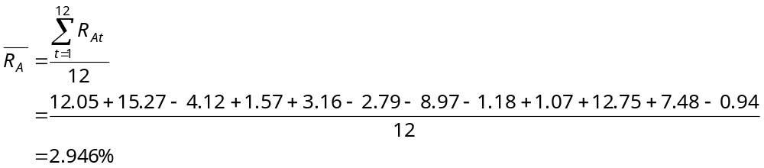

The sample mean monthly return on the market portfolio (the answer to part 1.E) is:
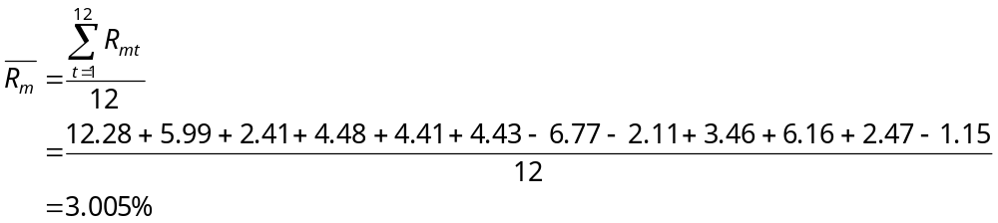

Using data given in the problem and the above two sample mean monthly returns, we have the following:
Month t 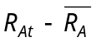 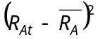 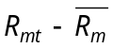 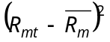 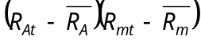
1 | 9.104 | 82.883 | 9.275 | 86.026 | 84.44
2 | 12.324 | 151.881 | 2.985 | 8.910 | 36.79
3 | -7.066 | 49.928 | -0.595 | 0.354 | 4.2
4 | -1.376 | 1.893 | 1.475 | 2.176 | -2.03
5 | 0.214 | 0.046 | 1.405 | 1.974 | 0.3
6 | -5.736 | 32.902 | 1.425 | 2.031 | -8.17
7 | -11.916 | 141.991 | -9.775 | 95.551 | 116.48
8 | -4.126 | 17.024 | -5.115 | 26.163 | 21.1
9 | -1.876 | 3.519 | 0.455 | 0.207 | -0.85
10 | 9.804 | 96.118 | 3.155 | 9.954 | 30.93
11 | 4.534 | 20.557 | -0.535 | 0.286 | -2.43
12 | -3.886 | 15.101 | -4.155 | 17.264 | 16.15

0.00 | 613.84 | 0.00 | 250.90 | 296.91
Sum
The sample variance and standard deviation of the stock A’s monthly return are:

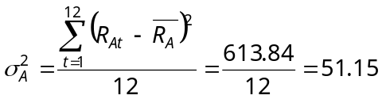

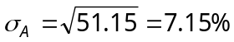

The sample variance (the answer to part 1.F) and standard deviation of the market portfolio’s monthly return are:

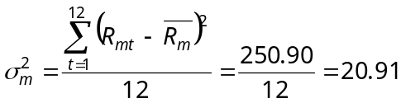

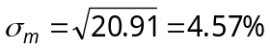

The sample covariance of the returns on stock A and the market portfolio is:

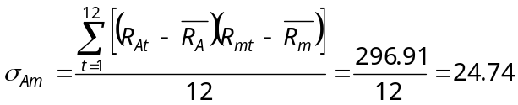

The sample correlation coefficient of the returns on stock A and the market portfolio (the answer to part 1.D) is:

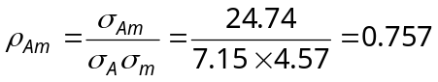

The sample beta of stock A (the answer to part 1.B) is:

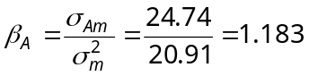

The sample alpha of stock A (the answer to part 1.A) is:

Each month’s sample residual is security A’s actual return that month minus the return that month predicted by the regression. The regression’s predicted monthly return is:

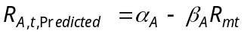
The sample residual for each month t is then:

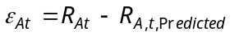

So we have the following:

Month t 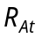 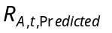 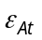 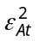
1 | 12.05 | 13.92 | -1.87 | 3.5
2 | 15.27 | 6.48 | 8.79 | 77.26
3 | -4.12 | 2.24 | -6.36 | 40.45
4 | 1.57 | 4.69 | -3.12 | 9.73
5 | 3.16 | 4.61 | -1.45 | 2.1
6 | -2.79 | 4.63 | -7.42 | 55.06
7 | -8.97 | -8.62 | -0.35 | 0.12
8 | -1.18 | -3.11 | 1.93 | 3.72
9 | 1.07 | 3.48 | -2.41 | 5.81
10 | 12.75 | 6.68 | 6.07 | 36.84
11 | 7.48 | 2.31 | 5.17 | 26.73
12 | -0.94 | -1.97 | 1.02 | 1.04
Sum: 0.00 262.36

Since the sample residuals sum to 0 (because of the way the sample alpha and beta are calculated), the sample mean of the sample residuals also equals 0 and the sample variance and standard deviation of the sample residuals (the answer to part 1.C) are:

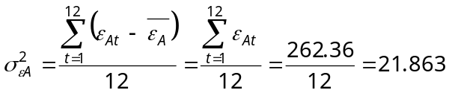

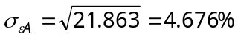

Repeating the above analysis for all the stocks in the problem yields:

 | Stock A | Stock B | Stock C
alpha | −0.609% | 2.964% | −3.422%
beta | 1.183 | 1.021 | 2.322
correlation  with market | 0.757 | 0.684 | 0.652
standard deviation  of sample residuals* | 4.676% | 4.983% | 12.341%

with 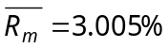 and 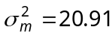.

*Note that most regression programs use N − 2 for the denominator in the sample residual variance formula and use N − 1 for the denominator in the other variance formulas (where N is the number of time series observations). As is explained in the text, we have instead used N for the denominator in all the variance formulas. To convert the variance from a regression program to our results, simply multiply the variance by either 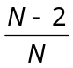 or 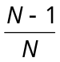.

Chapter 7: Problem 2

A.

A.1
The Sharpe single-index model's formula for a security's mean return is
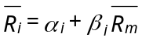
Using the alpha and beta for stock A along with the mean return on the market portfolio from Problem 1 we have:

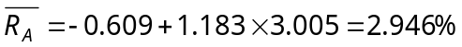

Similarly:

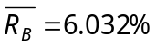; 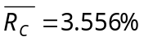

The Sharpe single-index model's formula for a security's variance of return is:

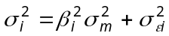

Using the beta and residual standard deviation for stock A along with the variance of return on the market portfolio from Problem 1 we have:

Similarly:

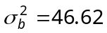; 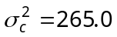

A.2
From Problem 1 we have:

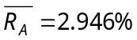; 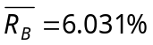; 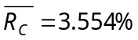

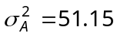; 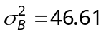; 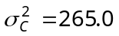

B.

B.1
According to the Sharpe single-index model, the covariance between the returns on a pair of assets is:

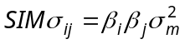

Using the betas for stocks A and B along with the variance of the market portfolio from Problem 1 we have:

Similarly:

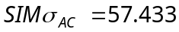; 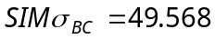

B.2
The formula for sample covariance from the historical time series of 12 pairs of returns on security i and security j is:

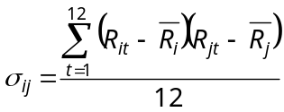

Applying the above formula to the monthly data given in Problem 1 for securities A, B and C gives:

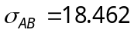; 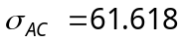; 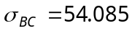

C.

C.1
Using the earlier results from the Sharpe single-index model, the mean monthly return and standard deviation of an equally weighted portfolio of stocks A, B and C are:

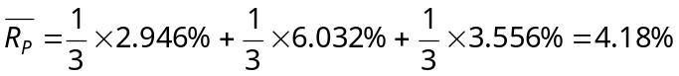

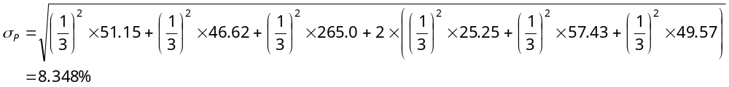
C.2
Using the earlier results from the historical data, the mean monthly return and standard deviation of an equally weighted portfolio of stocks A, B and C are:

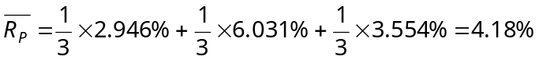

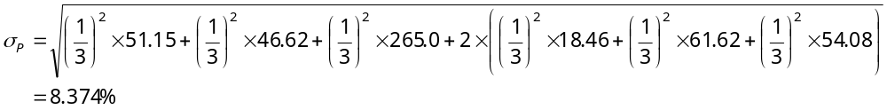

D.
The slight differences between the answers to parts A.1 and A.2 are simply due to rounding errors. The results for sample mean return and variance from either the Sharpe single-index model formulas or the sample-statistics formulas are in fact identical.

The answers to parts B.1 and B.2 differ for sample covariance because the Sharpe single-index model assumes the covariance between the residual returns of securities i and j is 0 (cov(ε_{i} ε_{j} ) = 0), and so the single-index form of sample covariance of total returns is calculated by setting the sample covariance of the sample residuals equal to 0. The sample-statistics form of sample covariance of total returns incorporates the actual sample covariance of the sample residuals.

The answers in parts C.1 and C.2 for mean returns on an equally weighted portfolio of stocks A, B and C are identical because the Sharpe single-index model formula for the mean return on an individual stock yields a result identical to that of the sample-statistics formula for the mean return on the stock.

The answers in parts C.1 and C.2 for standard deviations of return on an equally weighted portfolio of stocks A, B and C are different because the Sharpe single-index model formula for the sample covariance of returns on a pair of stocks yields a result different from that of the sample-statistics formula for the sample covariance of returns on a pair of stocks.

Chapter 7: Problem 3

Recall from the text that the Vasicek technique’s forecast of security i’s beta (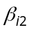) is:

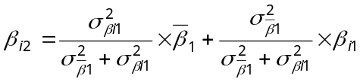

where 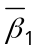 is the average beta across all sample securities in the historical period (in this problem referred to as the “market beta”), 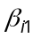 is the beta of security i in the historical period, 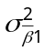 is the variance of all the sample securities’ betas in the historical period and 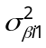 is the square of the standard error of the estimate of beta for security i in the historical period.

If the standard errors of the estimates of all the betas of the sample securities in the historical period are the same, then, for each security i, we have:
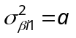
where a is a constant across all the sample securities.

Therefore, we have for any security i:

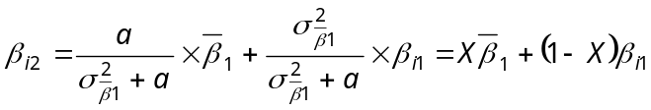

This shows that, under the assumption that the standard errors of all historical betas are the same, the forecasted beta for any security using the Vasicek technique is a simple weighted average (proportional weighting) of (the “market beta”) and (the security’s historical beta), where the weights are the same for each security.

Chapter 7: Problem 4

Letting the historical period of the year of monthly returns given in Problem 1 equal 1 (t = 1), then the forecast period equals 2 and the Blume forecast equation is:

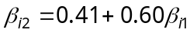

Using the earlier answer to Problem 1 for the estimate of beta from the historical period for stock A along with the above equation we obtain the stock’s forecasted beta:

Similarly:

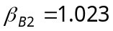; 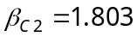

Chapter 7: Problem 5

A.
The single-index model's formula for security i's mean return is
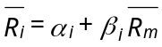

Since 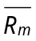 equals 8%, then, e.g., for security A we have:
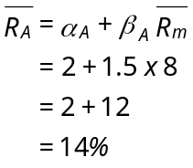

Similarly:

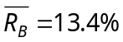; 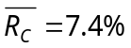; 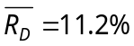

B.
The single-index model's formula for security i's own variance is:
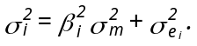

Since σ_{m} = 5, then, e.g., for security A we have:
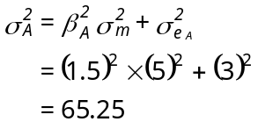

Similarly:

σ²_{B} = 43.25; σ²_{C} = 20; σ²_{D} = 36.25

C.
The single-index model's formula for the covariance of security i with security j is
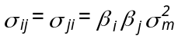

Since σ²_{m} = 25, then, e.g., for securities A and B we have:
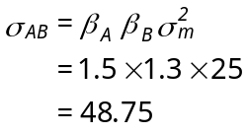

Similarly:

σ_{AC} = 30; σ_{AD} = 33.75; σ_{BC} = 26; σ_{BD} = 29.25; σ_{CD} = 18

Chapter 7: Problem 6

A.
Recall that the formula for a portfolio's beta is:

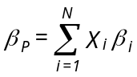

The weight for each asset (X_{i}) in an equally weighted portfolio is simply 1/N, where N is the number of assets in the portfolio.

Since there are four assets in Problem 5, N = 4 and X_{i} equals 1/4 for each asset in an equally weighted portfolio of those assets. So:
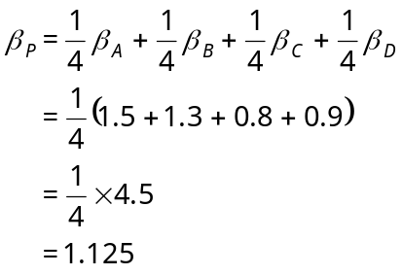

B.
Recall that the definition of a portfolio's alpha is:
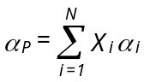

Using 1/4 as the weight for each asset, we have:
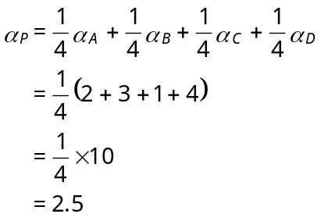
C.
Recall that a formula for a portfolio’s variance using the single-index model is:

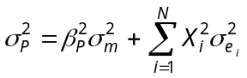

Using 1/4 as the weight for each asset, we have:

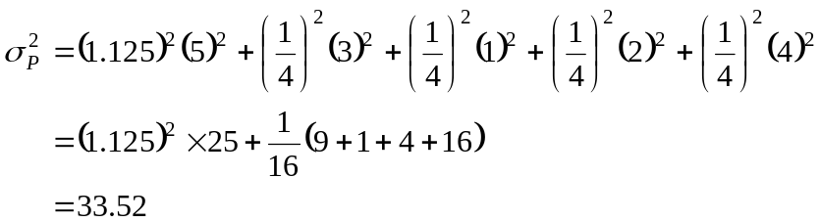

D.
Using the single-index model’s formula for a portfolio’s mean return we have:

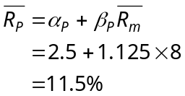

Chapter 7: Problem 7

Using 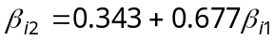 and the historical betas given in Problem 5 we can forecast, e.g., the beta for security A:

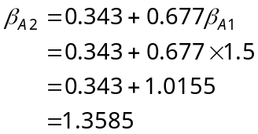

Similarly:

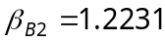; 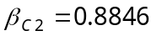; 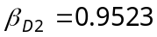

Chapter 7: Problem 8

Using the historical betas given in Problem 5 and Vasicek’s formula, we can forecast, e.g., the beta of security A:

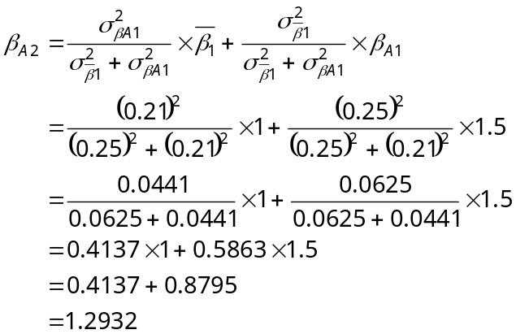

Similarly:

 